2015
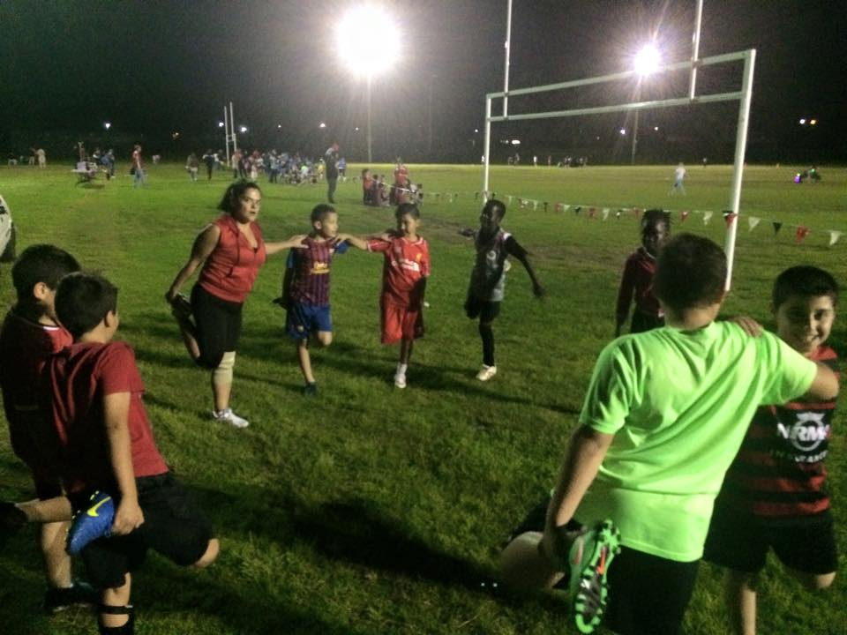
U10 stretch for the lapathon
Six a side
 | 
U9 Final – Guildford McCredie vs Lidcombe Churches | 2015 – U9 six a side champions!
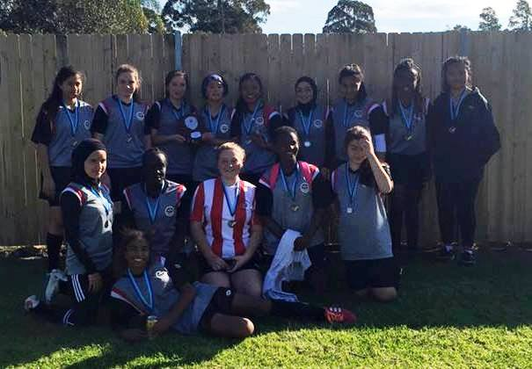 | 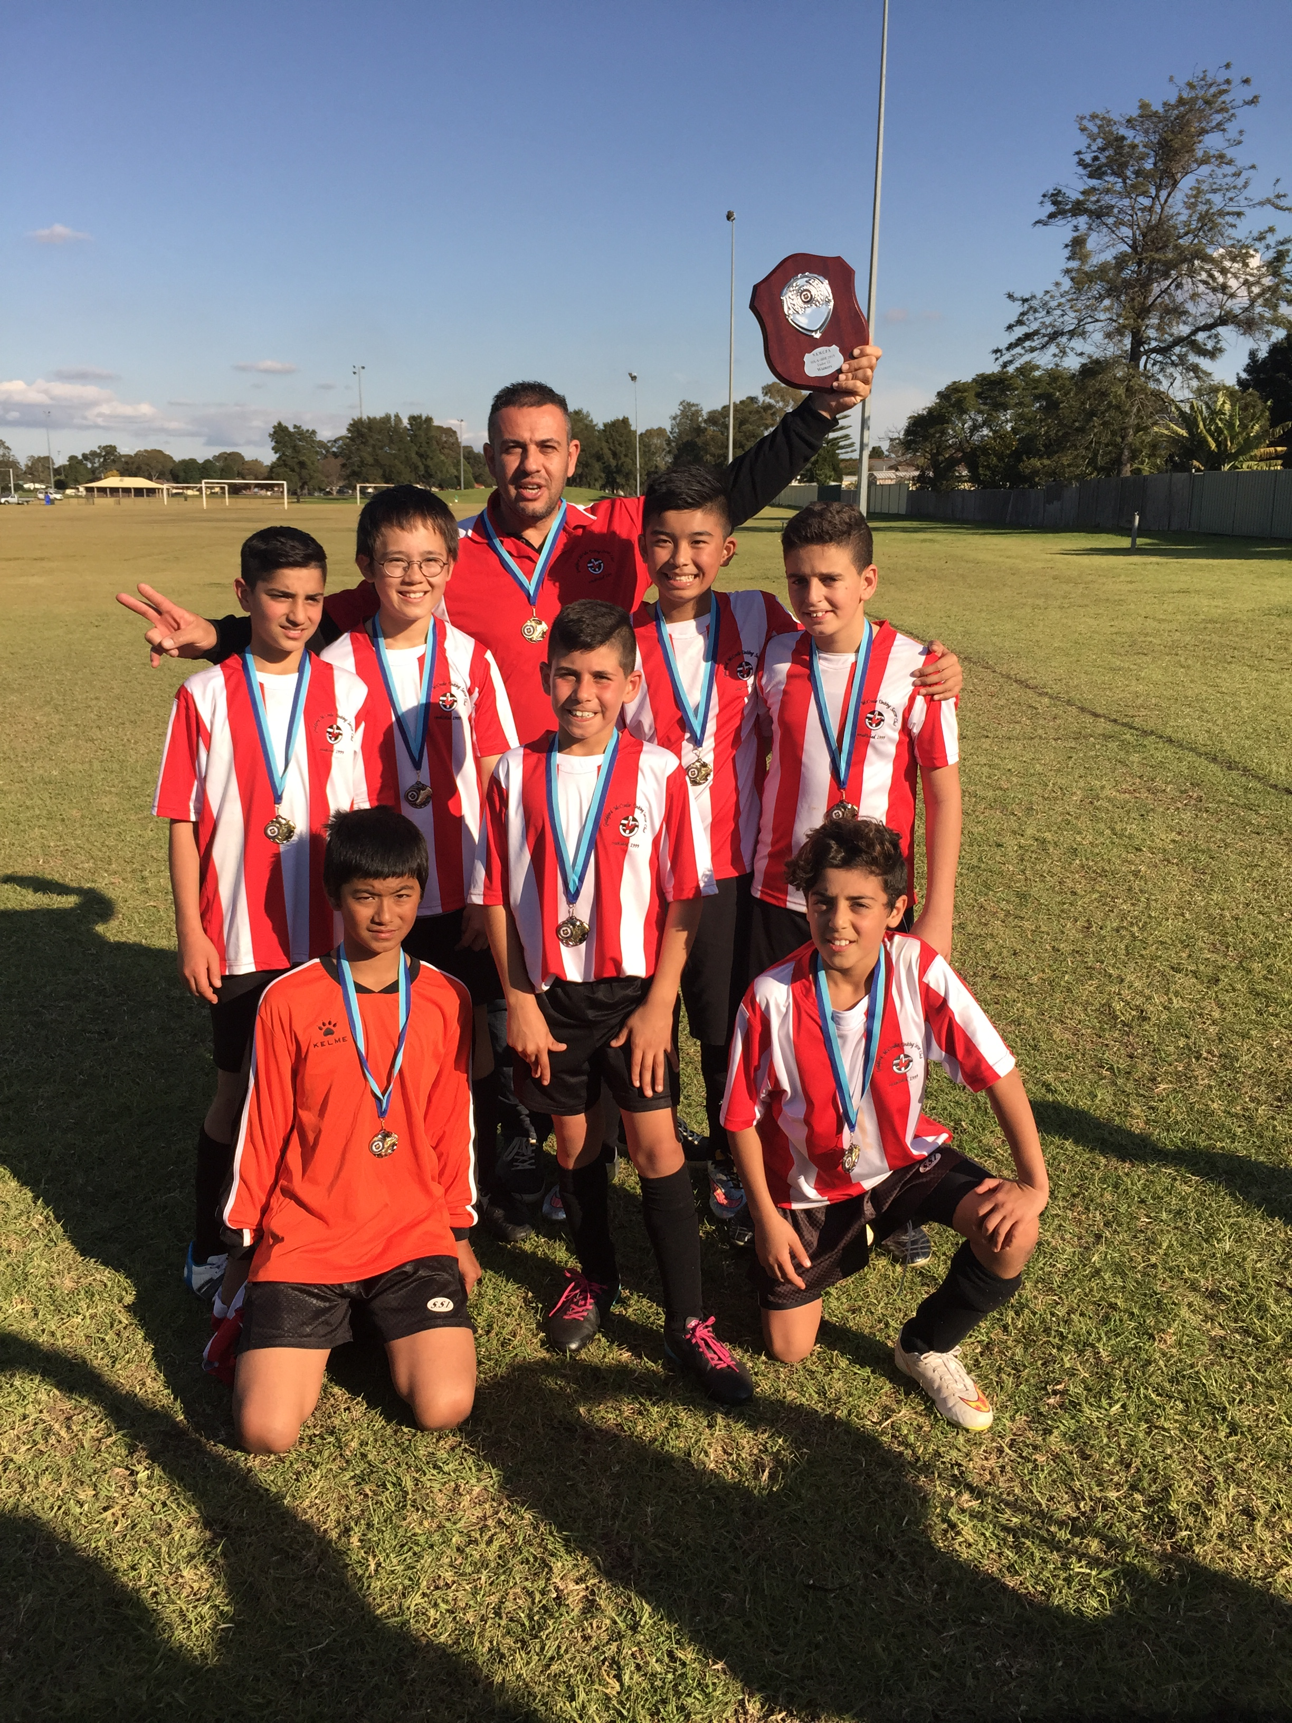
2015 U16 Girls Champions and Runners Up! | 2015 Under 12 six a side Champions!
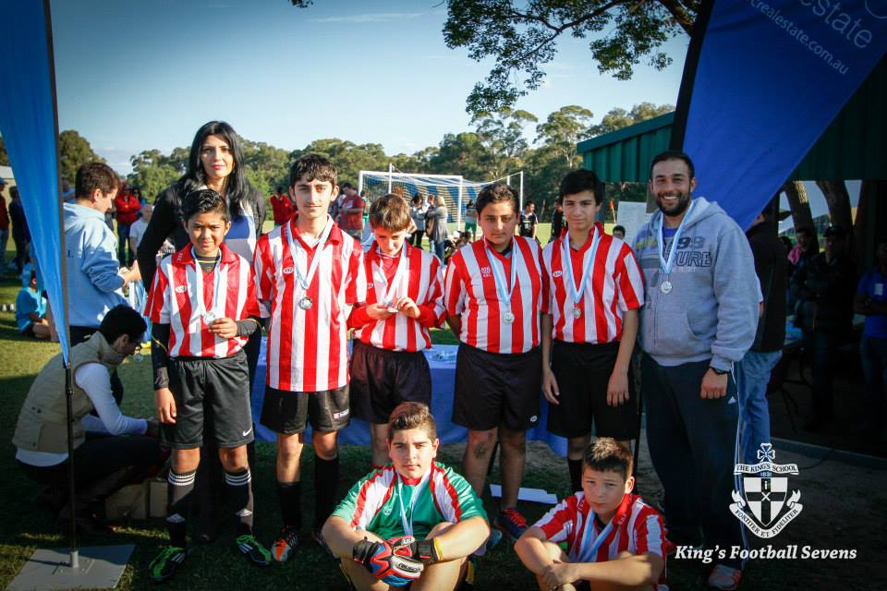 | 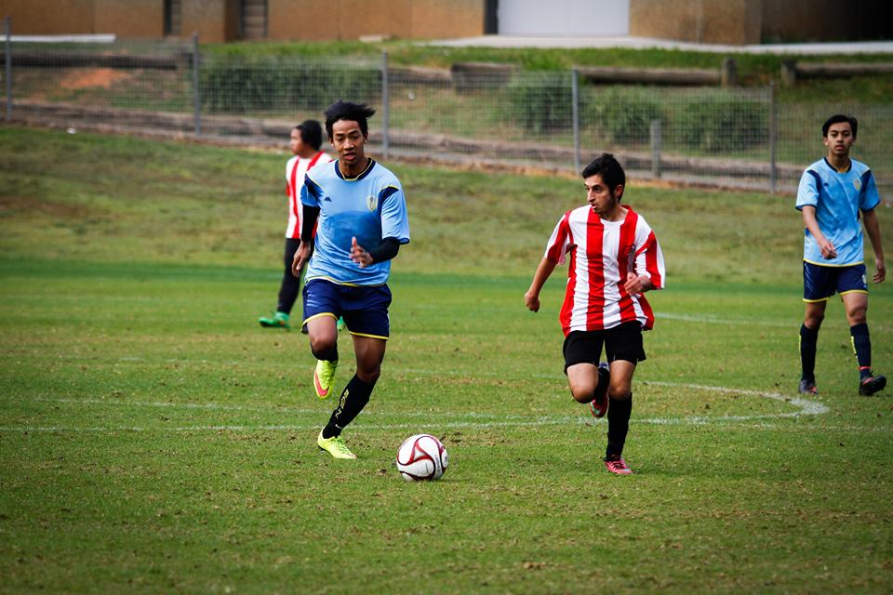
2015 U13 Kings Sevens Runners Up | Ahmad in action for the 17s at the Kings Sevens

