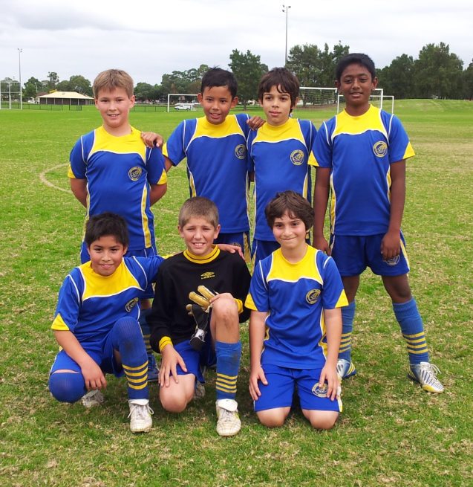

2013 U12 Gold six a side winners

